File permissions in Linux

Project description
Examine and manage the permissions on all files within the /home/researcher2/projects directory for the researcher2 user, who is a member of the research_team group. Permission checks must include all files in the directory, including hidden files, to ensure that they align with the level of authorization that should be given. When unnecessary or excessive permissions are found, they should be modified to the appropriate settings.

Check file and directory details
I navigated to the projects directory using cd projects and executed ls -la to display a detailed list of all files and directories, including hidden files such as .project_x.txt. This output includes file permissions, ownership, size, and last modification date for each item in the directory.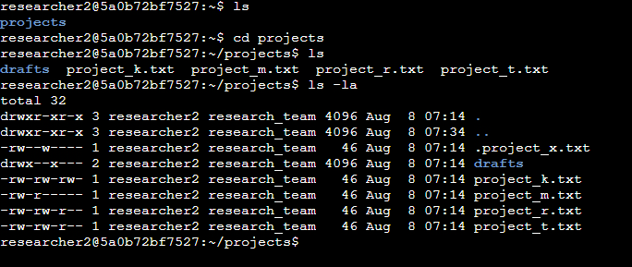

Describe the permissions string
Each file or directory in Linux has a 10-character string describing its type and permissions.

-rw-rw-r--
Position-by-position description (1st to 10th character):

Position | Example Char | Meaning
1 | - | File type — - means regular file, d means directory, l means symbolic link, etc.
2 | r | Owner’s read permission — r means the owner can read the file.
3 | w | Owner’s write permission — w means the owner can modify the file.
4 | - | Owner’s execute permission — x means the owner can execute the file (or enter the directory). - means no execute permission.
5 | r | Group’s read permission — r means members of the file’s group can read it.
6 | w | Group’s write permission — w means group members can modify it.
7 | - | Group’s execute permission — x means group members can execute or enter it.
8 | r | Others’ (world) read permission — r means anyone else can read it.
9 | - | Others’ write permission — w means anyone else can modify it.
10 | - | Others’ execute permission — x means anyone else can execute or enter it.

Change file permissions
In Linux, file and directory permissions determine who can read, write, or execute a given file.
The chmod (change mode) command allows you to modify these permissions for three types of users:
- u → User (the file owner)
- g → Group (members of the file’s group)
- o → Others (everyone else)
You can add (+), remove (-), or set permissions (=) for read (r), write (w), and execute (x) access.

Command Example | Description | Applies To
chmod u+(r/w/x) project_file_name | Adds the specified permission(s) to the file | Users (owner)
chmod u-(r/w/x) project_file_name | Removes the specified permission(s) from the file | Users (owner)
chmod g+(r/w/x) project_file_name | Adds the specified permission(s) to the file | Groups
chmod g-(r/w/x) project_file_name | Removes the specified permission(s) from the file | Groups
chmod o+(r/w/x) project_file_name | Adds the specified permission(s) to the file | Others
chmod o-(r/w/x) project_file_name | Removes the specified permission(s) from the file | Others

File Permission Changes:

- To remove write permissions for others from the file project_k.txt, I used the command:
chmod o-w project_k.txt

This ensures that users outside the owner and group cannot modify the file.
- To remove read permissions for the group from the file project_m.txt, I used the command:
chmod g-r project_m.txt

This prevents members of the file’s group from viewing its contents.
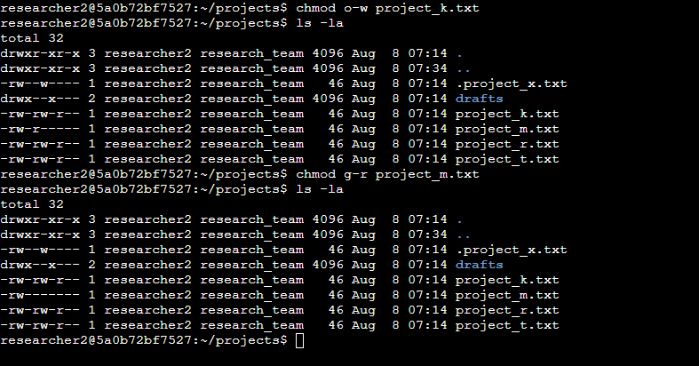

Change file permissions on a hidden file
The chmod command can also be used to adjust permissions for hidden files. For the hidden file .project_x.txt, I want to revoke write permissions for both users and the group while preserving read permissions for the group. The following single line of code accomplishes this:
chmod u-w,g-w,g+r .project_x.txt
To find hidden files, you can use the ls command with the -a option (e.g., ls -a or ls -la) to display all files, including those that start with a dot (.).
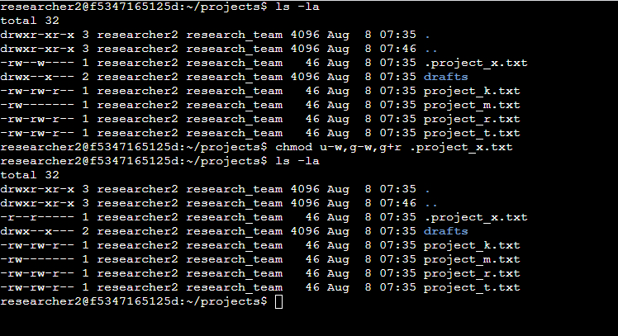

Change directory permissions
Directory permissions control access to directories, determining which users or groups can enter, read, or modify them. Common commands like chmod allow you to adjust these permissions effectively. For instance:
chmod g+x drafts
This command will grant access to the drafts directory exclusively to researcher2, a member of the research_team.
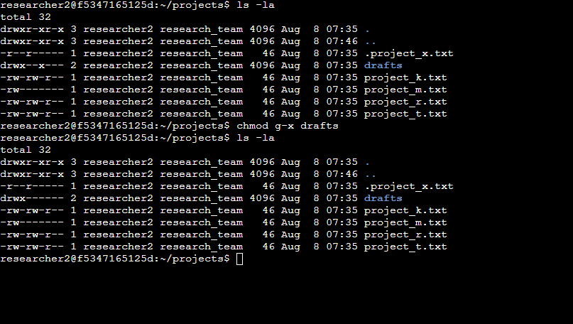

Summary
The scenario involved checking and managing permissions for files and directories in /home/researcher2/projects for user researcher2 (part of research_team). Using ls -la, all files, including hidden ones like .project_x.txt, were examined for permissions, ownership, and details. Permissions were adjusted with chmod:
- Removed write access for others on project_k.txt (chmod o-w).
- Removed group read access on project_m.txt (chmod g-r).
- For .project_x.txt, revoked owner/group write permissions, ensured group read access (chmod u-w,g-w,g+r).
- Granted group execute access to drafts directory (chmod g+x).
This ensured secure, appropriate access for files and directories.

